**Algorithm of Circular queue: FIFO**

1. Declare necessary variable:

i.e size=5, front=0, rear=-1, queue[size], count=0

1. For **Enqueue** operation:

Check queue full condition **i.e count==size**

**If** queue is full

Display “**The queue is full**” message.

Stop.

**else**

Read the data to be inserted [DTBI]

Increment the rear by 1 **i.e rear=(rear+1)%size;**

Store DTBI in queue[rear] **i.e queue[rear]=newdata**

Increment the count by 1 **i.e** **count++;**

1. To enqueue next data, repeat step 2.
2. For **Dequeue** operation:

Check queue empty condition **i.e count==0**

**If** queue is empty

Display “**The queue is empty**” message.

Stop.

**else**

Display the value of **queue[front]** i.e Display “**The data deleted from the queue is %d**” message.

Increment the front by 1 **i.e front=(front+1)%size;**

Decrement the count by 1 **i.e** **count--;**

1. To dequeue next data, repeat step 4.

**/* Circular queue lab number 3*/**

#include<stdio.h>

#include<conio.h>

#include<process.h>

#define size 5

int front=0,rear=-1,count=0;

int queue[size];

void enqueue()

{

if(count==size)

{

printf("Queue is full\n");

}

else

{

int data;

printf("Insert a data into a circular queue:\n");

scanf("%d",&data);

rear=(rear+1)%size;

queue[rear]=data;

count++;

}

}

void dequeue()

{

if(count==0)

{

printf("Queue is empty\n");

}

else

{

int data;

data=queue[front];

printf("The dequeue data is: %d",data);

front=(front+1)%size;

count--;

}

}

int main()

{

int choice;

clrscr();

do

{

printf("\nEnter your choice\n1.Enqueue\n2.Dequeue\n3.Exit\n");

scanf("%d",&choice);

switch(choice)

{

case 1:

enqueue();

break;

case 2:

dequeue();

break;

case 3:

exit(0);

}

}while(choice<=3);

getch();

return 0;

}

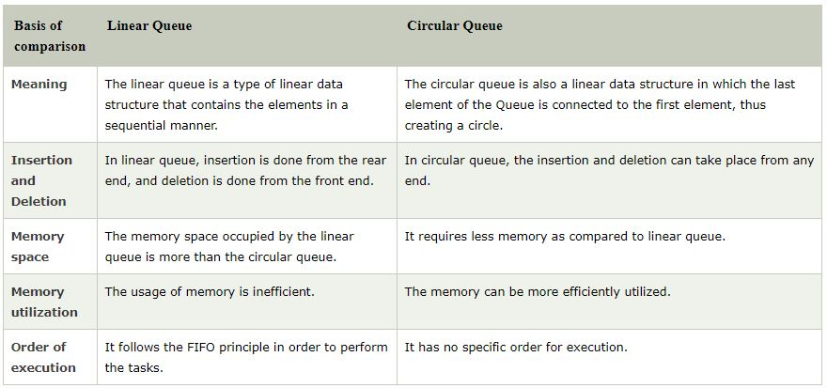

1. **Priority queue:**

Priority Queue is an extension of queue with following properties.

1. Every item has a priority associated with it.
2. An element with high priority is dequeue before an element with low priority.
3. If two elements have the same priority, they are served according to their order in the queue i.e first come first serve.

So it is a collection of elements such that each element has been assigned a priority and the order in which elements are deleted and processed comes from the rules:

1. An element of higher priority is processed before any element of lower priority.
2. Two elements with same priority are processed according to the order they were added to the queue.

In the below priority queue, element with maximum ASCII value will have the highest priority.

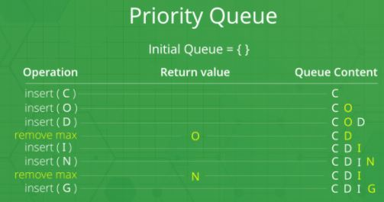

In a queue, the **first-in-first-out rule** is implemented whereas, in a priority queue, the values are removed **on the basis of priority**. The element with the highest priority is removed first.